PGA Tour, Champions, & Korn Ferry Tour
LED Scoreboard

Graphical Style Guide and Tournament Instructions

(Revised 2/1/22)

Section 1: Introduction

This document constitutes a style guide that tournaments shall use to create their local tournament graphics for the LED scoreboards.

It is recommended that tournaments appoint a staff member or volunteer with graphics experience to be the graphics chairperson (the point person to work on the graphics).

The TOUR has supplied a Photoshop template (.psd file) for creation of local tournament graphics to be submitted as PNG (.png) or JPEG (.jpg) files if you need it. It is posted to shotlink.com under LED scoreboards. A thirty-day trial of Photoshop CS or Elements can be downloaded from Adobe.com. Elements can be purchased for less than one hundred dollars. There are also free graphics applications available on the Web, such as GIMP.

The tournament logo must be in the left 30% of every slide and sponsor recognition must be on the right side. While it is preferred that you utilize verbiage to acknowledge secondary tournament sponsors, should secondary sponsor logos be used, logos must be accompanied with a designation massage (i.e., “Official Sponsor of…”, “Special Thanks To”, etc.). When recognizing a distilled spirit sponsor, the type of alcohol must not be used. Additionally, logos of distilled spirits companies must not include the type of spirit.

Web sites, URLs, Phone numbers, or domain names may not be put on any slides unless the Title Sponsor is a website, such as Frys.com. When referencing a tournament page on Facebook, the messaging can read: “Find us on Facebook.” It cannot read:
“Facebook.com/tournament.”

Tournaments can submit slides that display tournament staff names, tournament sponsor logos, pro-am and clinic information, and other tournament messaging.

Tournaments are responsible for the accuracy of spelling, dates, and times. If changes need to be made, new files must be re-submitted. The on-site staff cannot make these changes.

The TOUR will continue to create the full-screen tournament logo slide, so there is no need for the tournament graphics chairperson to create one.

Section 2: Examples from Tournaments

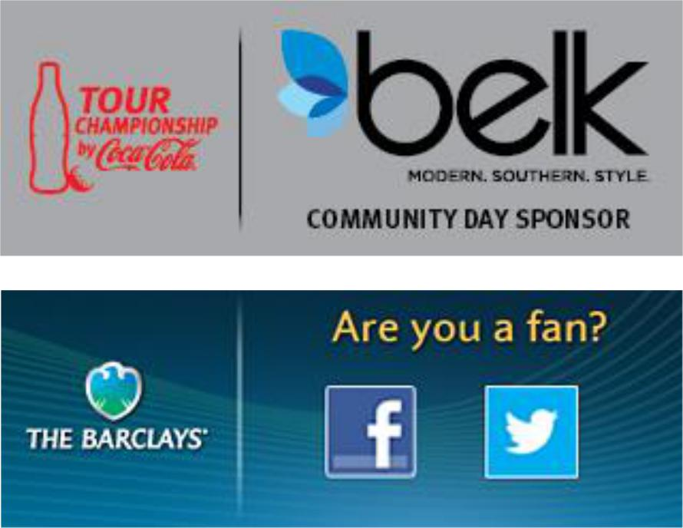

Section 3: Technical Specifications and Submission Guidelines

The Tour has three sizes of LED scoreboards.

- 624x312 – Modular Korn Ferry Tour only
- 608x228 – Large TOUR board

- 512x192 – Medium TOUR board

It is recommended that tournaments maintain their PSD file so that they can easily archive and update the slides as needed in the future.

While there is no specific deadline, keep in mind that until we receive your tournament files, we cannot run the content on the scoreboards. Once the files are submitted, they will go through an approval process. It is possible that some of the files may need to be modified by the tournament and re-submitted. To allow enough time for this process, we recommend submitting the files by Monday of advance week.

The tournament logo must be in the left 30% of every slide and sponsor recognition must be on the right side. While it is preferred that you utilize verbiage to acknowledge secondary tournament sponsors, should secondary sponsor logos be used, logos must be accompanied with a designation massage (i.e., “Official Sponsor of…”, “Special Thanks To”, etc.). When recognizing a distilled spirit sponsor, the type of alcohol must not be used. Additionally, logos of distilled spirits companies must not include the type of spirit. See below for examples.

Web sites, URLs, Phone numbers or domain names may not be put on any slides unless the Title Sponsor is a website, such as Frys.com. When referencing a tournament page on Facebook, the messaging can read: “Find us on Facebook.” It cannot read: “Facebook.com/tournament.”

Once you are ready to make the files, change the image size to make the size you have on site. It will either be 624x312, 608x228, or 512x192.

When saving the files, make sure to create PNG or JPEG files. The .png or .jpg extension must be preceded by a three-digit number, Tournament Name, and text to designate

the order in which the files are to show on the scoreboards and to help easily identify what the files are without having to open them. It is up to the tournament to order them how they want them to show. If a file needs to run up to a specific day such as a Tuesday clinic or a Wednesday pro-am, then the file should be named accordingly. Below is an example of how to name the files:
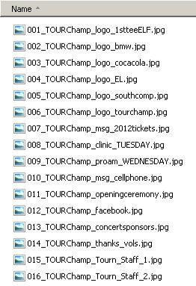

Once the PNG or JPEG slides are created, they need to be zipped up and emailed for approval to your Operations or TBA representative. Once approved, your representative will upload the files to the servers.

Section 4: How to use the template in Photoshop

Smooth, round, or bold fonts are recommended. Some examples are Univers, Arial, and Lucida. Italic fonts should not be used. Fonts should be no smaller than 14 pt. Text in all caps usually looks better but is not required.

Tournaments may change the color of the background; however, we strongly recommend dark backgrounds as they look best. Tournaments can also use a custom background and/or free form create their slides.

Remember that the tournament logo must be in the left 30% of every slide and Web sites, URLs, or domain names may not be put on any slides!

The best way to allow easy exporting and fixes (e.g. logo updates, spelling errors, date changes, or color changes) is to add a new layer for each additional element used to create the slide, and then save the template rather than renaming a single layer multiple times. That way, one template can be used to create all the tournament slides and the “eye” can be used to make elements visible or not visible as needed when saving the output files. In the two example images below, the single template contains all the layers that have been created for multiple output files.

In the next couple pages, samples will show how to get the desired messaging. Using the “eye” icon, layers will appear and disappear.

Once you have a selection of layers that you like, do a file save as and change the extension to .png of .jpg and name it as specified in the sections above. Make sure to duplicate layers to make more of the same item so you can go back and make edits. Don’t just edit the existing ones or you won’t have any backups. Also, save your PSD file so you don’t lose your work.

If you do not have the Univers font shown in the following examples on your computer, it is available at shotlink.com under LED scoreboards. Just copy it to your C:\windows\fonts directory or your /Users/Your_Username_Here/Library/Fonts directory on your Mac.

Once you are ready to make the files. Change the image size to make the size you have on site. It will either be 624x312, 608x228, or 512x192.

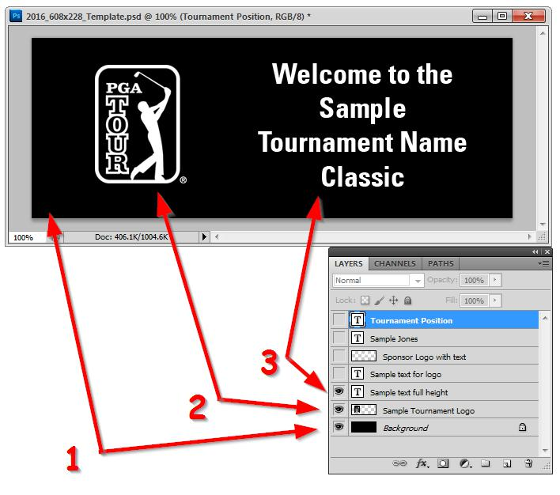

In the first sample above. #1 is the background. #2 is the tournament logo placement. #3 is the messaging that takes up the whole right side. For this example, you can replace the TOUR logo with your tournament logo. The text can be changed to match any wording you need.

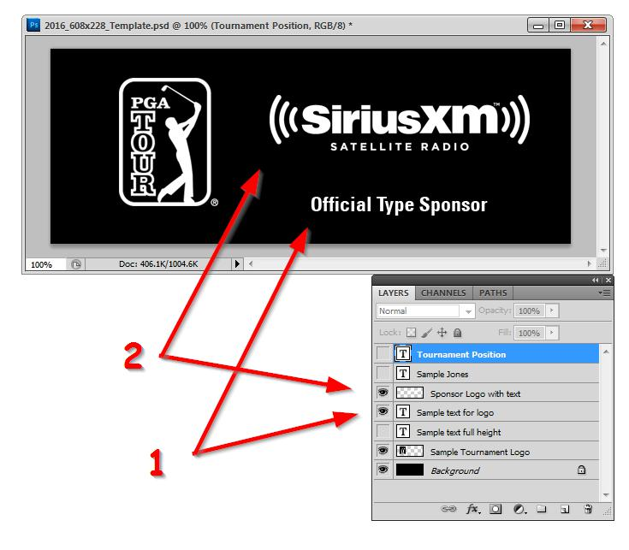

In the second sample above. #1 is the supporting text. #2 is the sponsor logo placement. For this example, you can replace the sponsor logo with any of your sponsor logos and the text can be changed to match any wording you need.

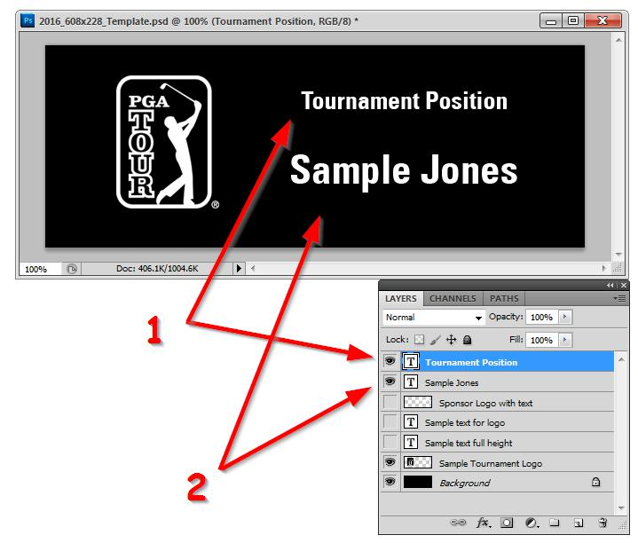

In the third sample above. #1 is the position title. #2 is the person’s name. Since you will most likely be giving credit to multiple people, just duplicate the layer and edit the new layer. This way, you can go back and make changes in the future.

Once you are ready to make the files. Change the image size to make the size you have on site. It will either be 624x312, 608x228, or 512x192. Then save the file as directed in the previous sections. Make sure not to save the PSD template in the smaller sizes. You can always use the history tool to undo any action.

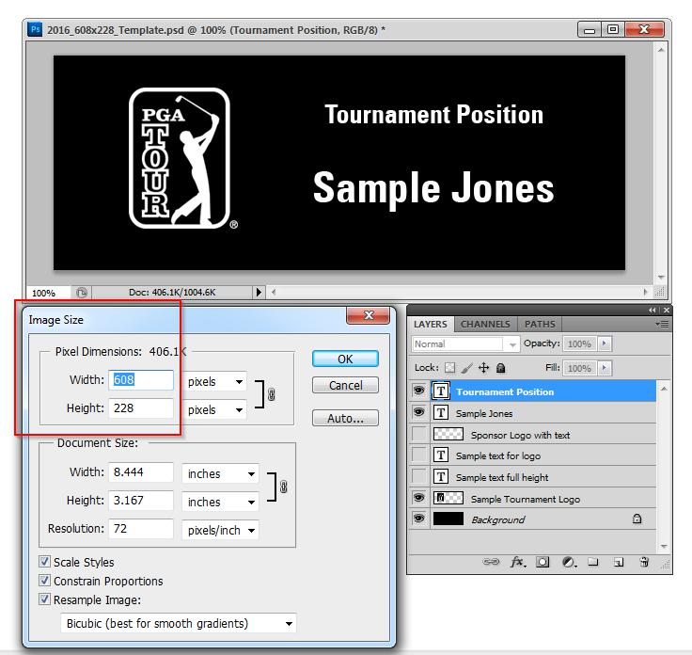

As a reminder, once the PNG or JPEG slides are created, they need to be zipped up and emailed for approval to your Operations or TBA representative. Once approved, your representative will upload the files to the servers.

